Rotate Kernel – CLI 1 60 lena_512x512_32bit.png lena_512x512_32bit

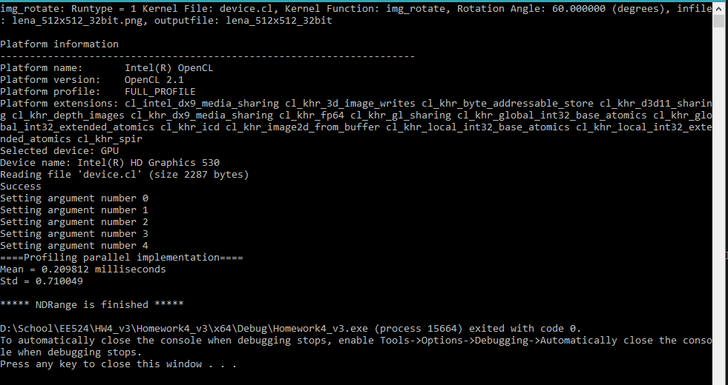

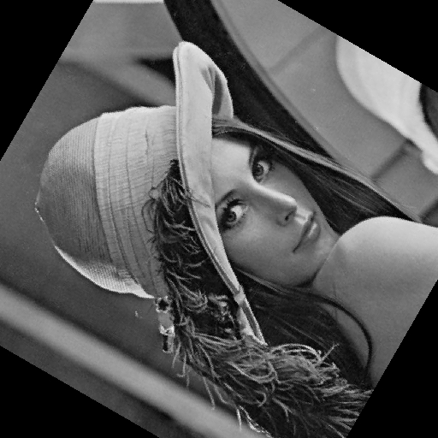

Blur Kernel – CLI 2 60 lena_512x512_32bit.png lena_512x512_32bit

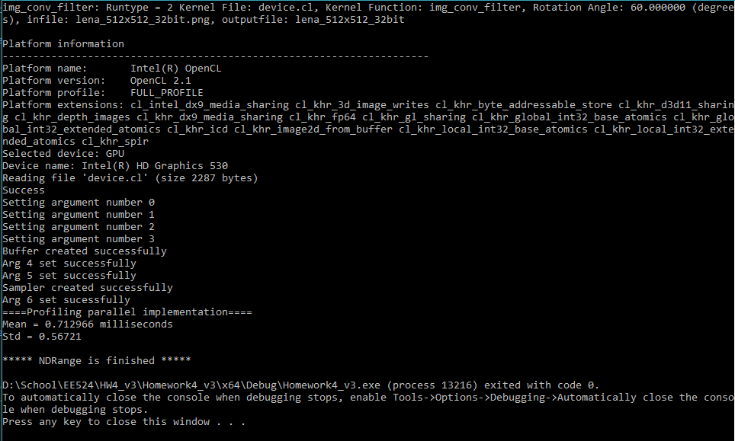



Parallel vs serial

lena_512x512_32bit



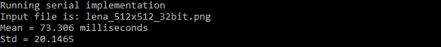

Big_Gray-Lena_8bit



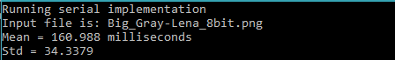

tiny-Lena_32bit



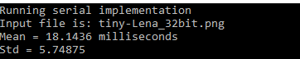

little-Lena_24bit



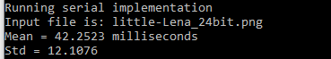

Parallel vs Serial execution times7

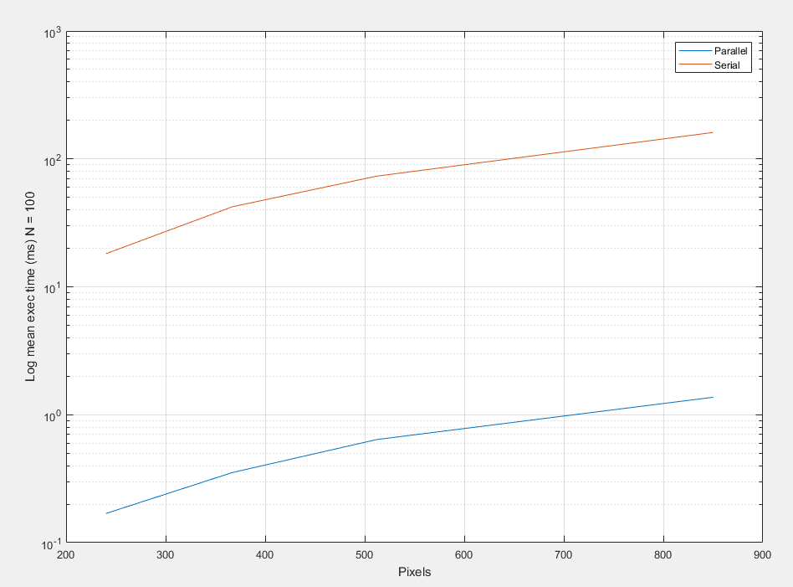

5x5



7x7



9x9

